Autumn (Fall)
# Source: AI Source: Provided by: [Data Path: Persons Table -> ID Column: 1, Name_En Column: Motasem Essam] -> From: [ChatGPT] on [7/17/2026]
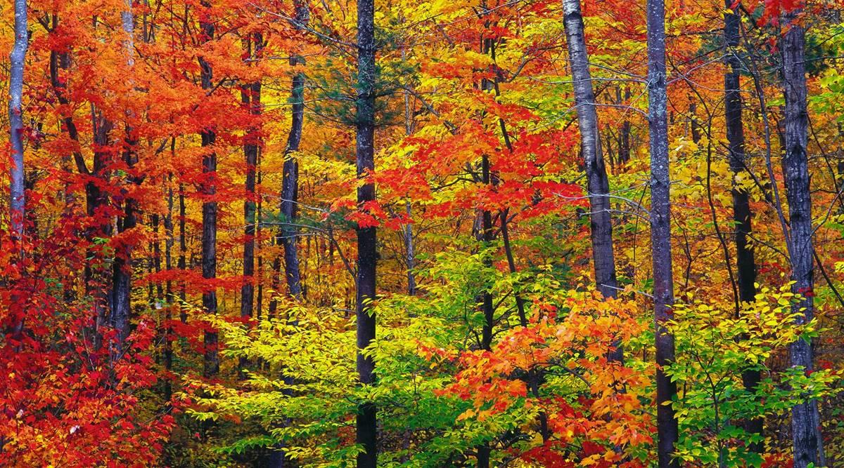
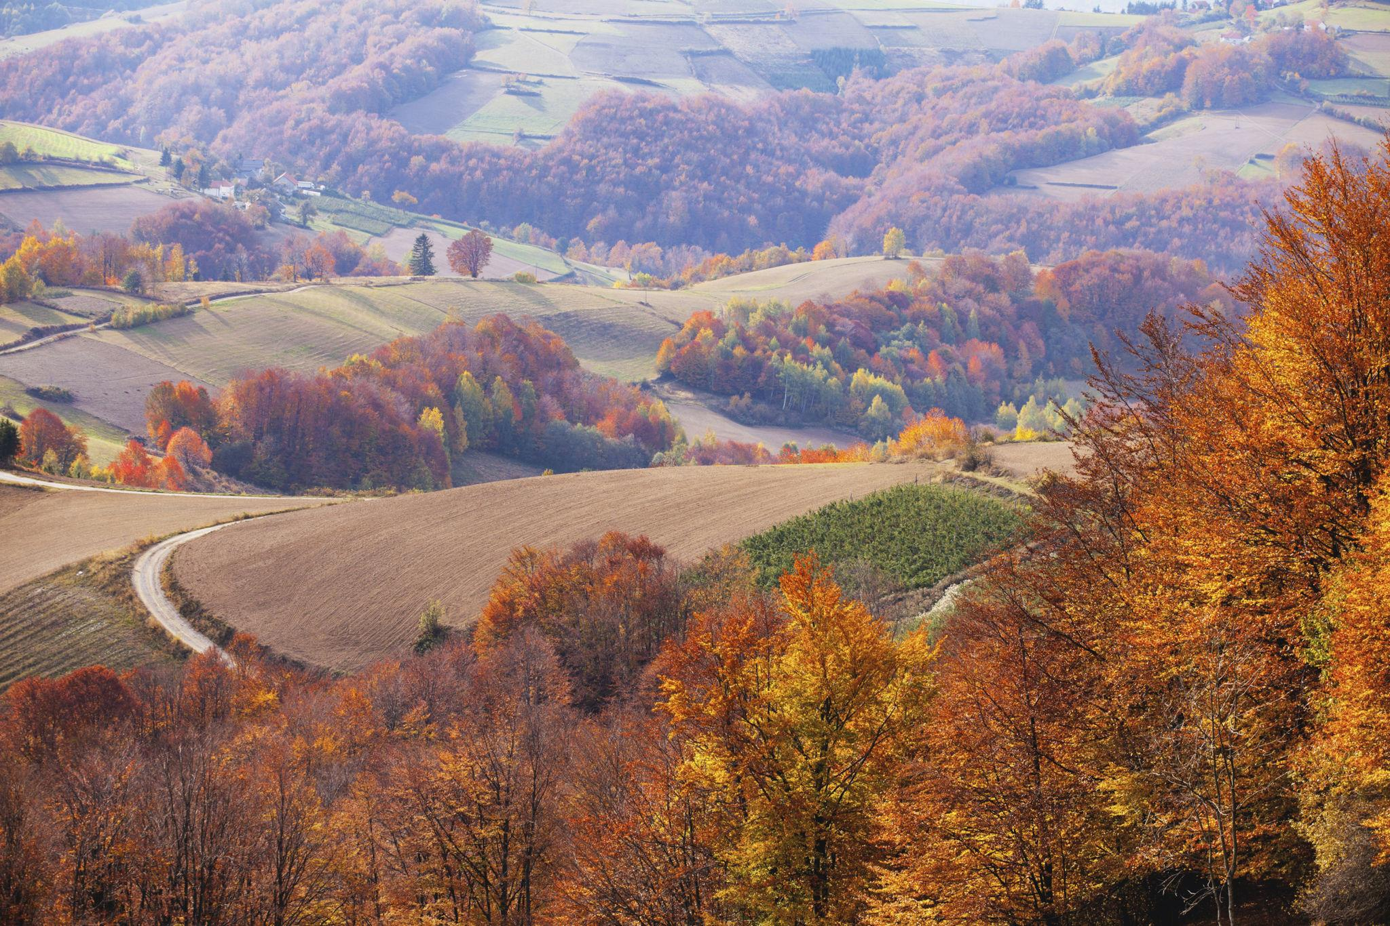
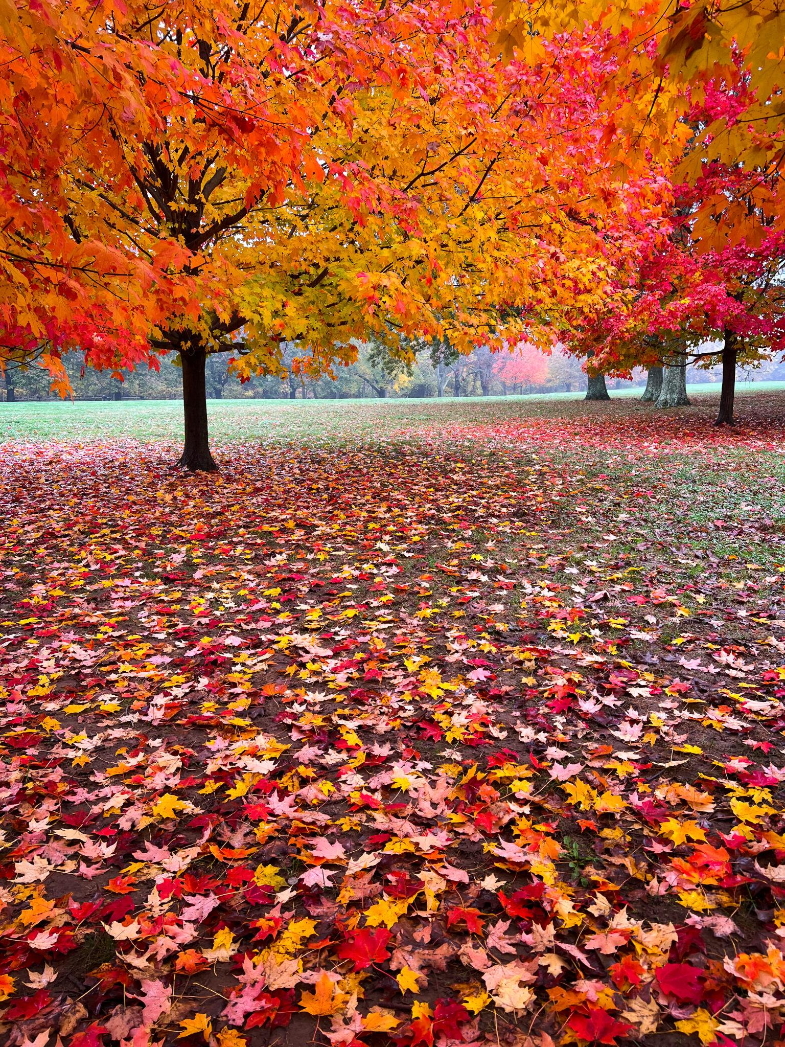
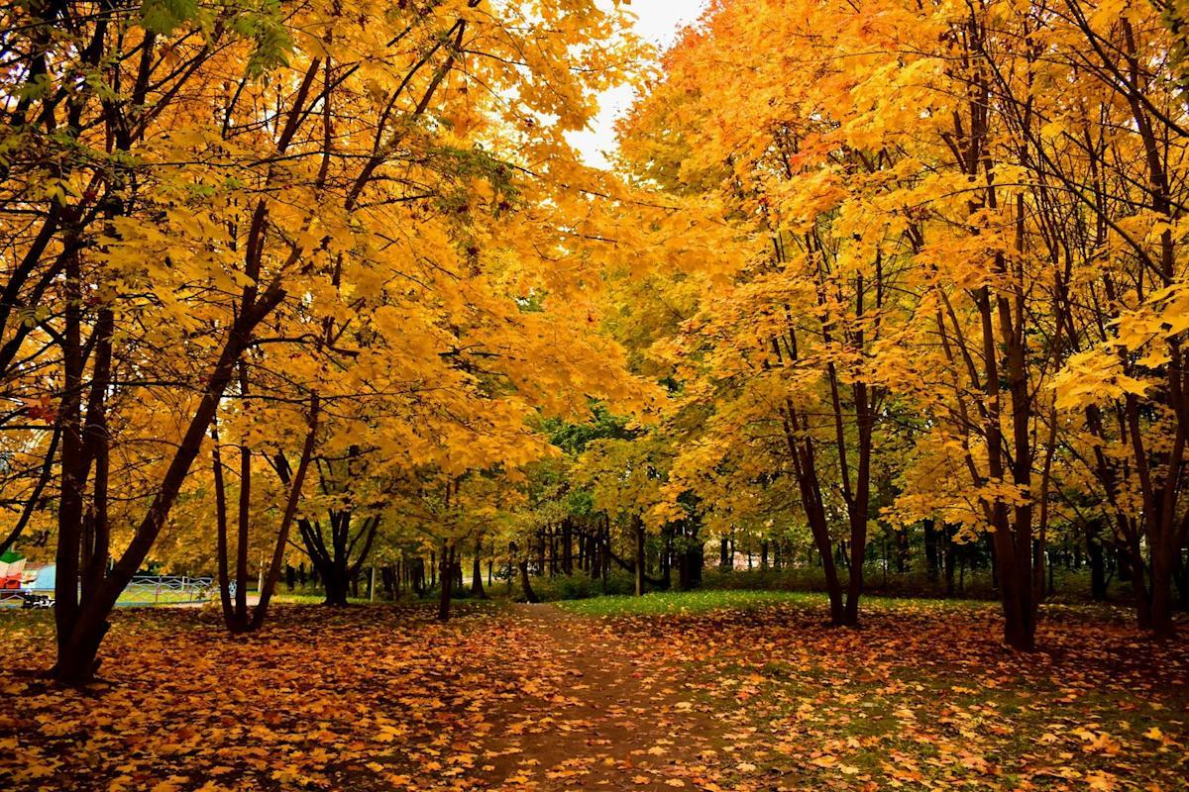
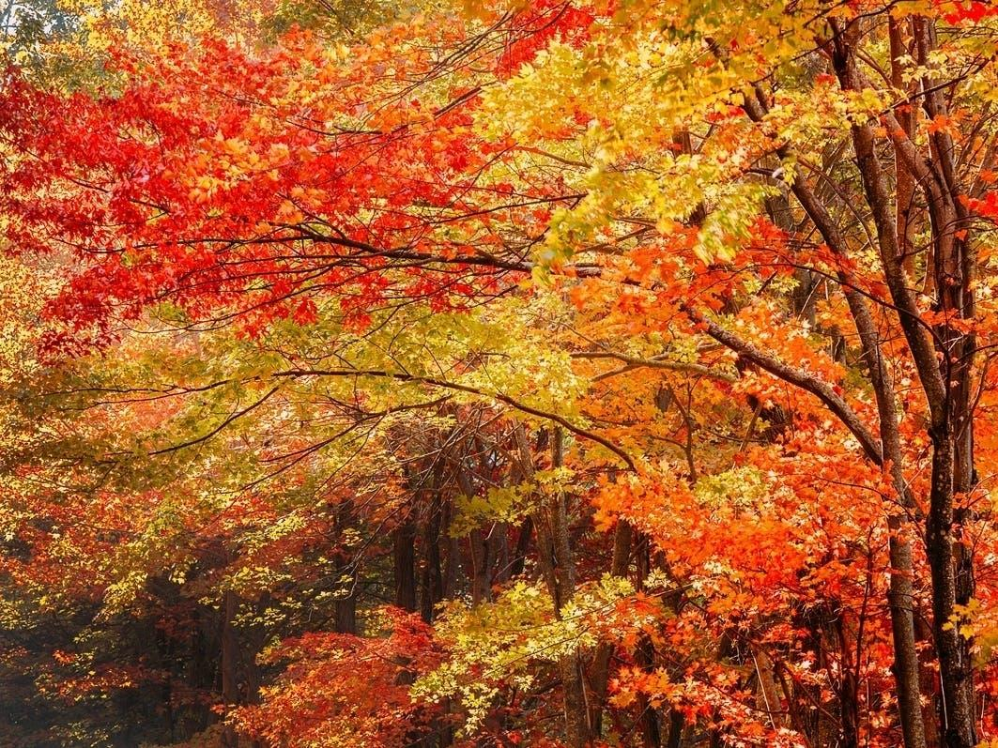
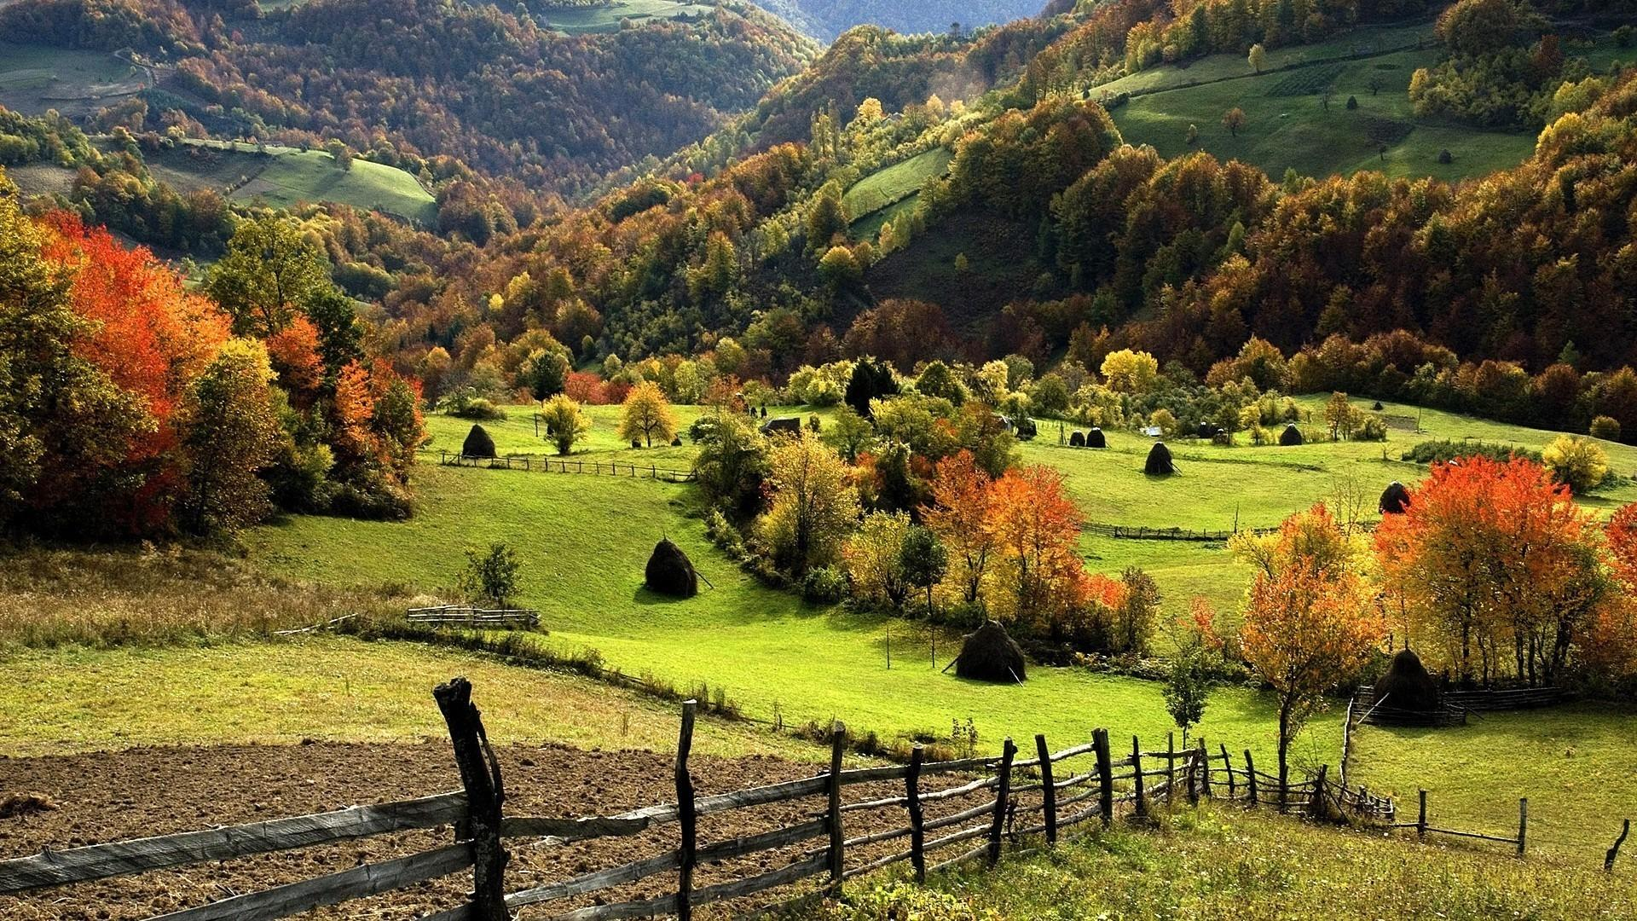
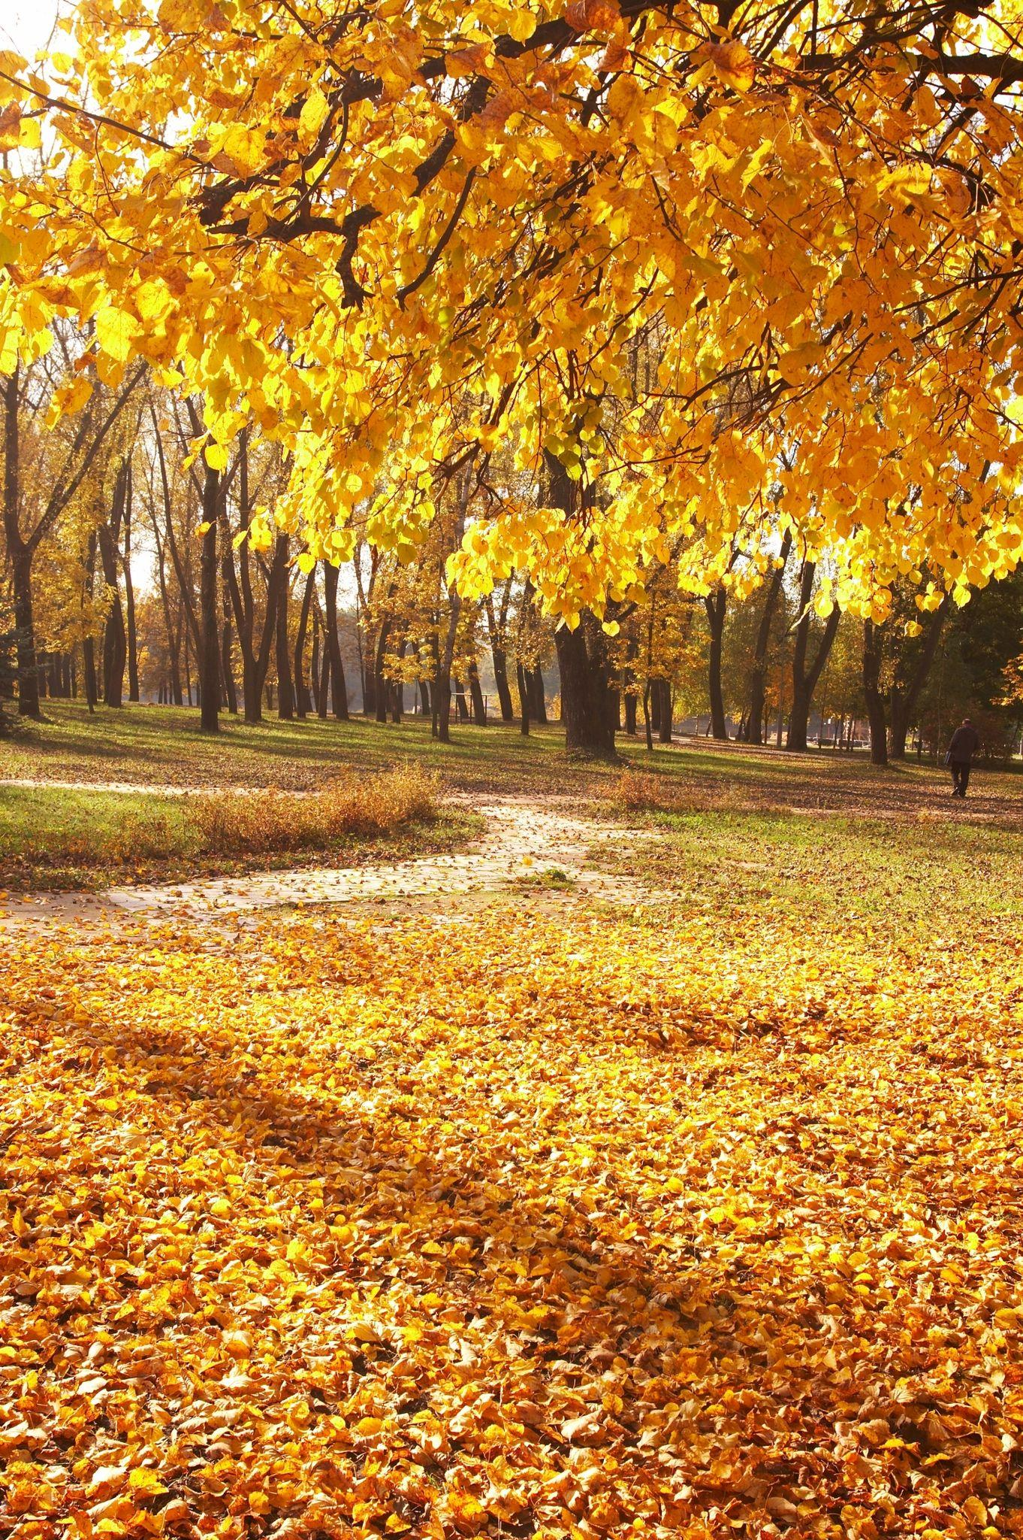
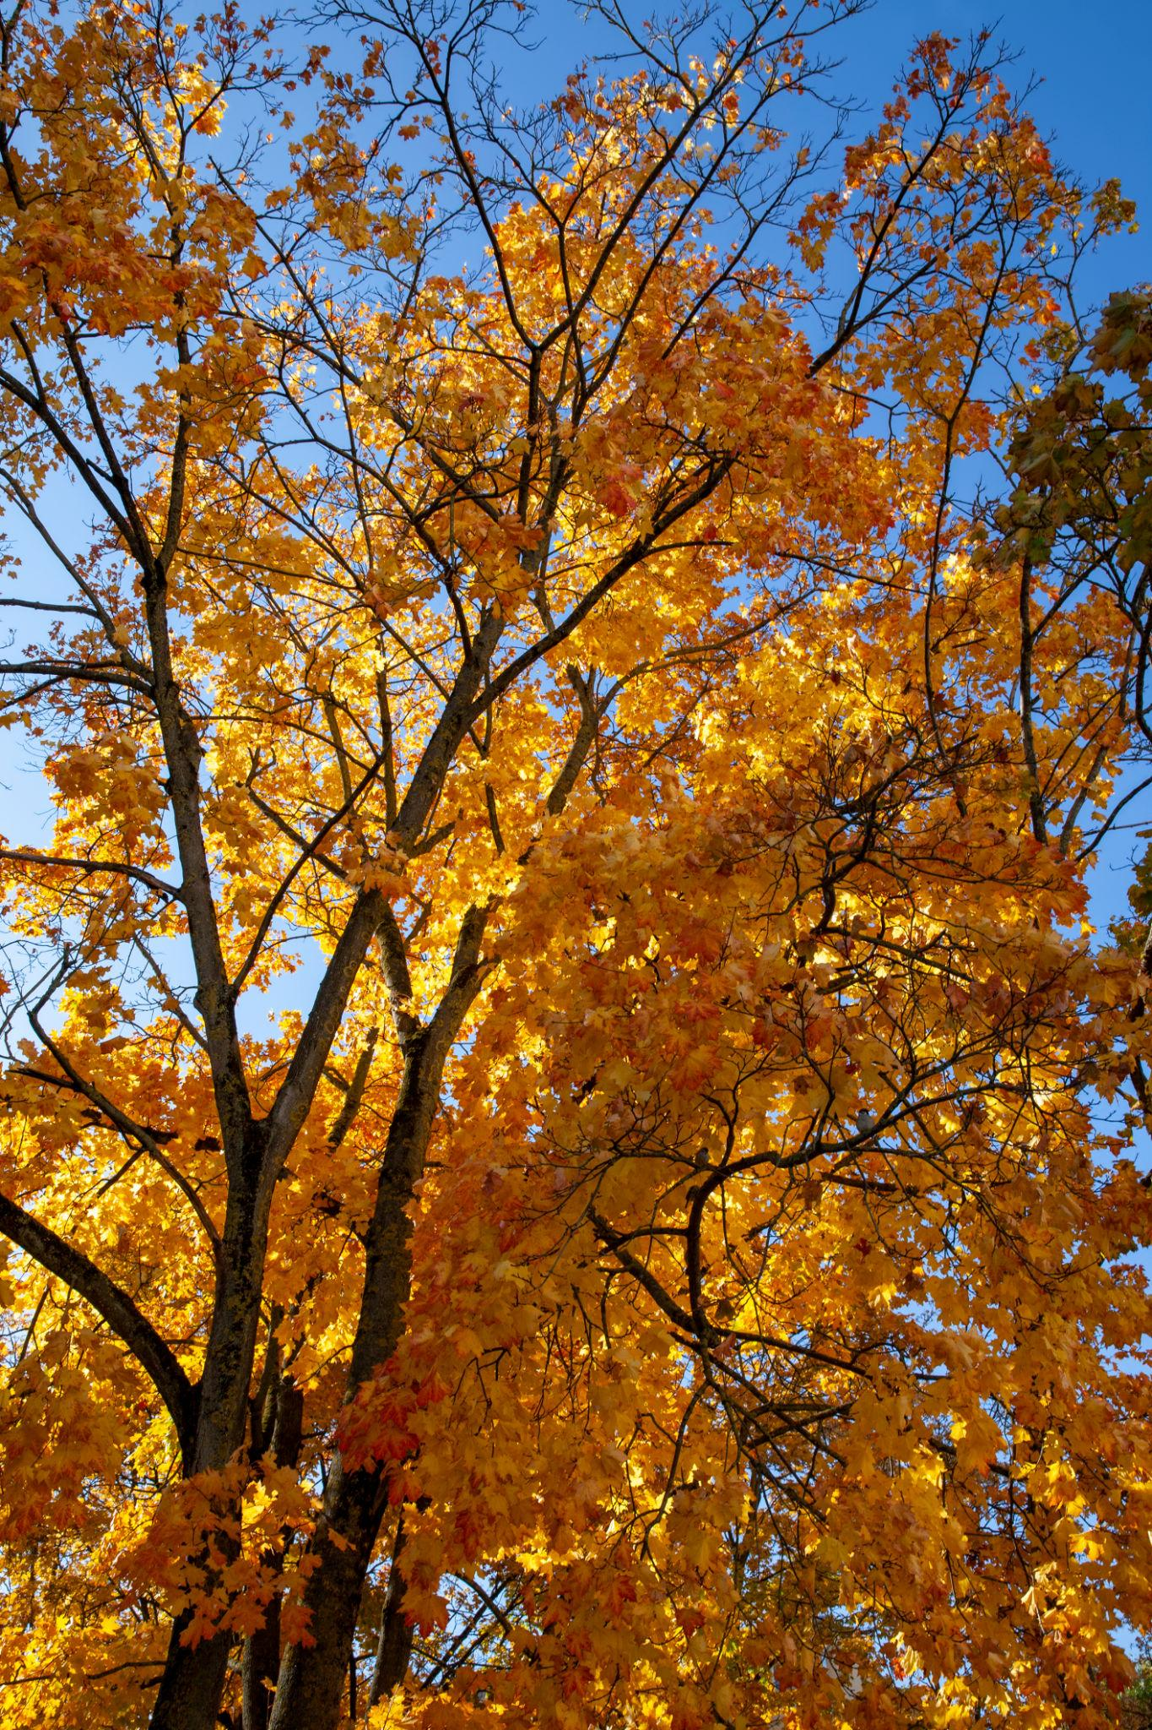
Autumn, also called Fall, is the season between summer and winter. It is characterized by cooler temperatures, shorter daylight hours, changing leaf colors, and the harvesting of many crops. In many regions, autumn marks the transition from the warmth of summer to the colder conditions of winter.
Autumn occurs because a hemisphere begins to tilt away from the Sun, receiving less direct sunlight each day.
The seasonal change is caused by the Earth's axial tilt and its orbit around the Sun.

Definition
# Source: AI Source: Provided by: [Data Path: Persons Table -> ID Column: 1, Name_En Column: Motasem Essam] -> From: [ChatGPT] on [7/17/2026]
Autumn (Fall) is the season between summer and winter, characterized by decreasing temperatures, shorter days, falling leaves, and the preparation of plants and animals for winter.

Position in the Year
# Source: AI Source: Provided by: [Data Path: Persons Table -> ID Column: 1, Name_En Column: Motasem Essam] -> From: [ChatGPT] on [7/17/2026]
Autumn occurs:
- After Summer
- Before Winter

Typical Months
# Source: AI Source: Provided by: [Data Path: Persons Table -> ID Column: 1, Name_En Column: Motasem Essam] -> From: [ChatGPT] on [7/17/2026]
Northern Hemisphere
- September
- October
- November
Southern Hemisphere
- March
- April
- May

Beginning of Autumn
# Source: AI Source: Provided by: [Data Path: Persons Table -> ID Column: 1, Name_En Column: Motasem Essam] -> From: [ChatGPT] on [7/17/2026]
Astronomical Autumn
Autumn begins at the:
- Autumnal Equinox
Around:
- September 22–23 (Northern Hemisphere)
- March 20–21 (Southern Hemisphere)
At the equinox:
- Day and night are approximately equal in length.

Weather Characteristics
# Source: AI Source: Provided by: [Data Path: Persons Table -> ID Column: 1, Name_En Column: Motasem Essam] -> From: [ChatGPT] on [7/17/2026]
Autumn weather is generally:
- Mild to cool
- Less humid in many regions
- Windier than summer
- More frequent rainfall in some climates
Typical conditions include:
- Comfortable daytime temperatures
- Cooler nights
- Morning fog in some areas
- Occasional storms

Temperature
# Source: AI Source: Provided by: [Data Path: Persons Table -> ID Column: 1, Name_En Column: Motasem Essam] -> From: [ChatGPT] on [7/17/2026]
During autumn:
- Average temperatures gradually decrease.
- Heat from summer slowly fades.
- Frost may begin appearing late in the season in colder regions.

Daylight
# Source: AI Source: Provided by: [Data Path: Persons Table -> ID Column: 1, Name_En Column: Motasem Essam] -> From: [ChatGPT] on [7/17/2026]
During autumn:
- Days become progressively shorter.
- Nights become longer.
- The Sun appears lower in the sky each day.

Changes in Nature
# Source: AI Source: Provided by: [Data Path: Persons Table -> ID Column: 1, Name_En Column: Motasem Essam] -> From: [ChatGPT] on [7/17/2026]
Autumn is a season of preparation for winter.
Plants
- Leaves change color.
- Many deciduous trees shed their leaves.
- Fruits and seeds mature.
- Plant growth slows.
Animals
- Birds migrate to warmer regions.
- Many animals gather food.
- Some animals prepare for hibernation.
- Fur becomes thicker in some species.

Why Do Leaves Change Color?
# Source: AI Source: Provided by: [Data Path: Persons Table -> ID Column: 1, Name_En Column: Motasem Essam] -> From: [ChatGPT] on [7/17/2026]
Leaves appear green because of chlorophyll, the pigment used in photosynthesis.
As daylight decreases and temperatures cool:
- Chlorophyll breaks down.
- Other pigments become visible, producing colors such as:
  - Yellow
  - Orange
  - Red
  - Brown
Eventually, many trees shed their leaves to conserve water and energy during winter.

Agriculture
# Source: AI Source: Provided by: [Data Path: Persons Table -> ID Column: 1, Name_En Column: Motasem Essam] -> From: [ChatGPT] on [7/17/2026]
Autumn is one of the main harvest seasons.
Common activities include:
- Harvesting grains
- Collecting fruits
- Harvesting vegetables
- Preparing fields for winter
- Storing crops

Human Activities
# Source: AI Source: Provided by: [Data Path: Persons Table -> ID Column: 1, Name_En Column: Motasem Essam] -> From: [ChatGPT] on [7/17/2026]
People often:
- Harvest crops.
- Enjoy hiking in colorful forests.
- Celebrate harvest festivals.
- Prepare homes for colder weather.
- Return to school after summer holidays (in many countries).

Major Autumn Celebrations
# Source: AI Source: Provided by: [Data Path: Persons Table -> ID Column: 1, Name_En Column: Motasem Essam] -> From: [ChatGPT] on [7/17/2026]
Examples include:
- Harvest festivals
- Thanksgiving (Canada and the United States)
- Mid-Autumn Festival (East Asia)
- Oktoberfest (Germany)
- Halloween (many countries)

Importance of Autumn
# Source: AI Source: Provided by: [Data Path: Persons Table -> ID Column: 1, Name_En Column: Motasem Essam] -> From: [ChatGPT] on [7/17/2026]
Autumn is important because it:
- Marks the harvest season.
- Helps ecosystems prepare for winter.
- Supports seed dispersal.
- Signals migration and hibernation.
- Contributes to nutrient recycling as fallen leaves decompose.

Advantages
# Source: AI Source: Provided by: [Data Path: Persons Table -> ID Column: 1, Name_En Column: Motasem Essam] -> From: [ChatGPT] on [7/17/2026]
Autumn provides:
- Comfortable temperatures
- Beautiful scenery
- Harvested food supplies
- Lower heat levels
- Pleasant outdoor conditions

Challenges
# Source: AI Source: Provided by: [Data Path: Persons Table -> ID Column: 1, Name_En Column: Motasem Essam] -> From: [ChatGPT] on [7/17/2026]
Autumn may also bring:
- Early frosts
- Strong winds
- Heavy leaf fall
- Shorter daylight
- Increased rainfall in some regions

Comparison with Other Seasons
# Source: AI Source: Provided by: [Data Path: Persons Table -> ID Column: 1, Name_En Column: Motasem Essam] -> From: [ChatGPT] on [7/17/2026]
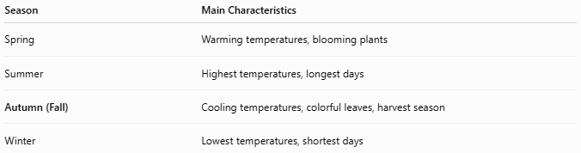
Season | Main Characteristics
Spring | Warming temperatures, blooming plants
Summer | Highest temperatures, longest days
Autumn (Fall) | Cooling temperatures, colorful leaves, harvest season
Winter | Lowest temperatures, shortest days

Common Mistakes
# Source: AI Source: Provided by: [Data Path: Persons Table -> ID Column: 1, Name_En Column: Motasem Essam] -> From: [ChatGPT] on [7/17/2026]
- Assuming all trees lose their leaves (evergreen trees generally retain their leaves year-round).
- Believing leaf color changes occur only because of cold weather (reduced daylight is the primary trigger).
- Assuming autumn begins on the same calendar date worldwide (the date depends on the hemisphere and whether astronomical or meteorological seasons are used).

Key Points
# Source: AI Source: Provided by: [Data Path: Persons Table -> ID Column: 1, Name_En Column: Motasem Essam] -> From: [ChatGPT] on [7/17/2026]
- Autumn (Fall) is the season between summer and winter.
- It begins at the Autumnal Equinox.
- Temperatures gradually decrease.
- Daylight becomes shorter.
- Leaves change color and many trees shed them.
- Animals prepare for winter through migration, food storage, or hibernation.
- Autumn is an important harvest season.

Conclusion
# Source: AI Source: Provided by: [Data Path: Persons Table -> ID Column: 1, Name_En Column: Motasem Essam] -> From: [ChatGPT] on [7/17/2026]
Autumn (Fall) is the season of transition from the warmth of summer to the cold of winter. As the Earth receives less direct sunlight, temperatures gradually decline, daylight hours shorten, and ecosystems begin preparing for winter. The changing colors of leaves, the migration of birds, and the harvesting of crops make autumn one of the most visually striking and agriculturally significant seasons of the year.

